Java Problemsheet - 8

Name: Kaaviya S S Roll. no: 22PT15

1. Write a java program that reads a file name from the user then displays information about whether that file exists, file is writable, the type of file and length of the file in bytes.

import java.io.*;
import java.util.Scanner;

public class FileExistance {
public static void main(String args[])
{
Scanner obj = new Scanner(System.in);

System.out.print("Enter the file name: ");
String filename = obj.nextLine();

File f = new File(filename);

System.out.println("File Name: " + f.getName());
System.out.println("Path: " + f.getPath());
System.out.println("Abs Path: " + f.getAbsolutePath());
System.out.println("Parent: " + f.getParent());
System.out.println(f.exists() ? "exists" : "does not exist");
System.out.println(f.canWrite() ? "is writeable" : "is not writeable");
System.out.println(f.canRead() ? "is readable" : "is not readable");
System.out.println("File last modified: " + f.lastModified());
System.out.println("File size: " + f.length() + " Bytes");

obj.close();
}
}

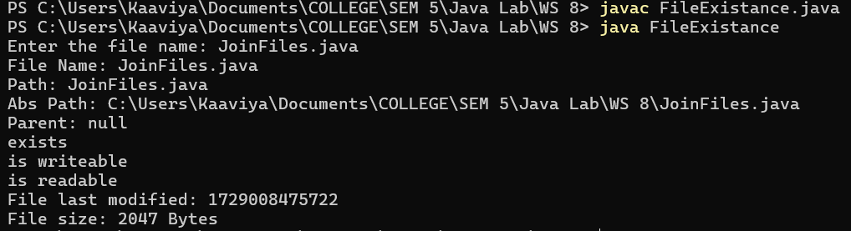

—------------------------------------------------------------------------------------------------------------------

2. Write a java program to join lines of two given files and store them in a new file.

import java.io.*;
import java.util.Scanner;

public class JoinFiles {
public static void main(String[] args) {

Scanner obj = new Scanner(System.in);

System.out.print("Enter the 1st file name: ");
String file1 = obj.nextLine();
System.out.print("Enter the 2nd file name: ");
String file2 = obj.nextLine();
System.out.print("Enter the output file name: ");
String output = obj.nextLine();

//Creating file objects
File firstFile = new File(file1);
File secondFile = new File(file2);
File outputFile = new File(output);

if(!firstFile.exists() || !secondFile.exists()) {
System.out.println("Either one or both of the files does not exist!");
}

try {
BufferedReader reader1 = new BufferedReader(new FileReader(firstFile));
BufferedReader reader2 = new BufferedReader(new FileReader(secondFile));
BufferedWriter writer = new BufferedWriter(new FileWriter(outputFile));

String line1,line2;

while( (line1 = reader1.readLine())!=null && (line2 = reader2.readLine())!=null )
{
writer.write(line1);
writer.newLine();
writer.write(line2);
writer.newLine();
}

//write the remaining left off lines from file1 and file2
while( (line1 = reader1.readLine())!=null )
{
writer.write(line1);
writer.newLine();
}
while( (line2 = reader2.readLine())!=null )
{
writer.write(line2);
writer.newLine();
}

System.out.println("Files joined successfully!");
reader1.close();
reader2.close();
writer.close();

} catch (IOException e) {
System.out.println("Error joining files : " + e.getMessage());
}

obj.close();
}
}

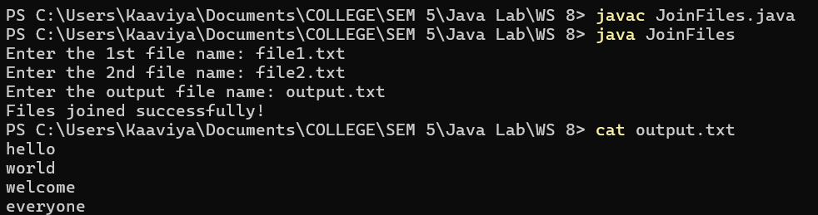

—------------------------------------------------------------------------------------------------------------------

3.Write a java program that reads a file and displays the file contents on the screen with a line number before each line.

import java.io.BufferedReader;
import java.io.FileReader;
import java.io.IOException;

public class NumberedFile
{ public static void main(String[] args)
{
String fileName = "output.txt";
try {
FileReader file= new FileReader(fileName);
BufferedReader reader = new BufferedReader(file);

String line;
int lineNumber = 1;

while ((line = reader.readLine()) != null) {
System.out.println(lineNumber + ": " + line);
lineNumber++;
}

reader.close();
}
catch (IOException e) {
e.printStackTrace();
}
}

}

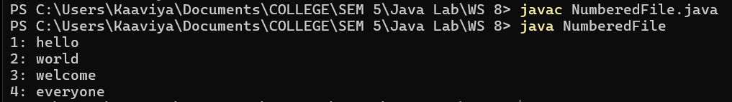

—------------------------------------------------------------------------------------------------------------------

4. Write a java program to collect Statistics of a source file like total lines, total no. of blank lines, total no. of lines ending with semicolon.

import java.io.BufferedReader;
import java.io.FileReader;
import java.io.IOException;

public class FileStatistics {
public static void main(String[] args) {
String fileName = "NumberedFile.java";
int totalLines = 0;
int blankLines = 0;
int semicolonLines = 0;
try {
BufferedReader br = new BufferedReader(new FileReader(fileName));

String line;

while ((line = br.readLine()) != null)
{
totalLines++;
if (line.trim().isEmpty())
blankLines++;
if (line.trim().endsWith(";"))
semicolonLines++;
}
br.close();

} catch (IOException e) {
e.printStackTrace();
}
System.out.println("Total Lines: " + totalLines);
System.out.println("Blank Lines: " + blankLines);
System.out.println("Lines ending with semicolon: " + semicolonLines);
}
}

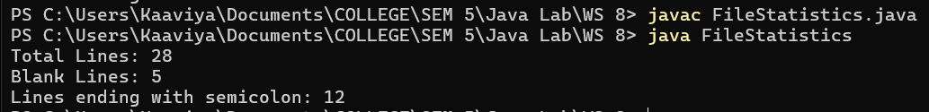

—------------------------------------------------------------------------------------------------------------------

5. Using a text editor, create a file that contains a list of at least 15 six-digit account numbers. Read in each account number and display whether it is valid. An account number is valid only if the last digit is equal to the remainder when the sum of the first five digits is divided by 10. For example, the number 223355 is valid because the sum of the first five digits is 15, the remainder when 15 is divided by 10 is 5, and the last digit is 5. Write only valid account numbers to an output file, each on its own line.

import java.io.*;

public class ValidAccount
{
public static boolean isValidAccountNumber(String number)
{
if(number.length()!=6)
return false;

int sum=0;
for(int i=0; i<5; i++)
{
char digit = number.charAt(i);
if (!Character.isDigit(digit))
return false;
sum += Character.getNumericValue(digit);
}

int last_digit = Character.getNumericValue(number.charAt(5));

return (sum%10)==last_digit;
}

public static void main(String[] args) {
String inputFile = "account_num.txt";
String outputFile = "valid_num.txt";

try {
BufferedReader br = new BufferedReader(new FileReader(inputFile));
BufferedWriter bw = new BufferedWriter(new FileWriter(outputFile));

String accountNumber;
while ((accountNumber = br.readLine()) != null) {
if (isValidAccountNumber(accountNumber)) {
bw.write(accountNumber);
bw.newLine(); //for line breaks
}
}
System.out.println("Valid account numbers have been written to " + outputFile);

br.close();
bw.close();

} catch (IOException e) {
e.printStackTrace();
}
}
}

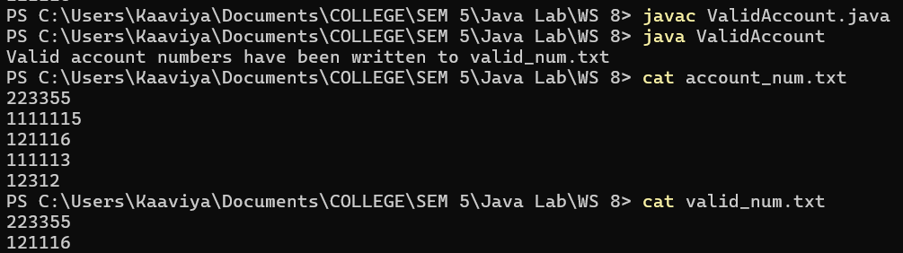

—------------------------------------------------------------------------------------------------------------------

6. Create class FileMatch to perform the file-matching functionality. The class should contain methods that read oldmast.txt and trans.txt. When a match occurs (i.e., records with the same account number appear in both the master file and the transaction file), add the dollar amount in the transaction record to the current balance in the master record, and write the
"newmast.txt" record. (Assume that purchases are indicated by positive amounts in the transaction file and payments by negative amounts.) When there’s a master record for a particular account, but no corresponding transaction record, merely write the master record to "newmast.txt". When there’s a transaction record, but no corresponding master record, print to a log file the message "Unmatched transaction record for account number..." (fill in the account number from the transaction record). The log file should be a text file named "log.txt".

import java.io.*;

public class FileMatch {

public static String[] readTransactionFile(BufferedReader transactionReader) throws IOException
{
StringBuilder transactionBuilder = new StringBuilder();
String transactionLine;
while ((transactionLine = transactionReader.readLine()) != null) {
transactionBuilder.append(transactionLine).append("\n");
}
return transactionBuilder.toString().split("\n");
}

public static String[] removeTransactionRecord(String[] transactionLines, String accountNumber)
{
StringBuilder newTransactionLinesBuilder = new StringBuilder();
for (String transactionLine : transactionLines)
{
String[] transactionFields = transactionLine.split("\\s+");
if (!transactionFields[0].equals(accountNumber)) {
newTransactionLinesBuilder.append(transactionLine).append("\n");
}
}
return newTransactionLinesBuilder.toString().split("\n");
}

public static void matchFiles()
{
String masterFile = "oldmast.txt";
String transactionFile = "trans.txt";
String newMasterFile = "newmast.txt";
String logFile = "log.txt";

try
{
BufferedReader masterReader = new BufferedReader(new FileReader(masterFile));
BufferedReader transactionReader = new BufferedReader(new FileReader(transactionFile));
BufferedWriter newMasterWriter = new BufferedWriter(new FileWriter(newMasterFile));
BufferedWriter logWriter = new BufferedWriter(new FileWriter(logFile));

String[] transactionLines = readTransactionFile(transactionReader);

String masterLine;
while ((masterLine = masterReader.readLine()) != null)
{
String[] masterFields = masterLine.split("\\s+");
String accountNumber = masterFields[0];
double balance = Double.parseDouble(masterFields[1]);
boolean transactionFound = false;

// Check for matching transaction record
for (String transactionLine : transactionLines)
{
String[] transactionFields = transactionLine.split("\\s+");
if (transactionFields[0].equals(accountNumber)) {
balance += Double.parseDouble(transactionFields[1]);
transactionFound = true;
break;
}
}
// Write updated master record
newMasterWriter.write(accountNumber + " " + balance);
newMasterWriter.newLine();

// If a transaction was found, remove it from the transaction list
if (transactionFound) {
transactionLines = removeTransactionRecord(transactionLines, accountNumber);
}
}

// Log remaining unmatched transaction records
for (String transactionLine : transactionLines)
{
if (!transactionLine.trim().isEmpty()) {
String[] transactionFields = transactionLine.split("\\s+");
logWriter.write("Unmatched transaction record for account number " + transactionFields[0]);
logWriter.newLine();
}
}

System.out.println("File matching complete. Updated master records saved to 'newmast.txt'.");
System.out.println("Unmatched transactions logged to 'log.txt'.");

masterReader.close();
transactionReader.close();
newMasterWriter.close();
logWriter.close();

} catch (IOException e) {
e.printStackTrace();
}
}
public static void main(String[] args) {
matchFiles();
}
}

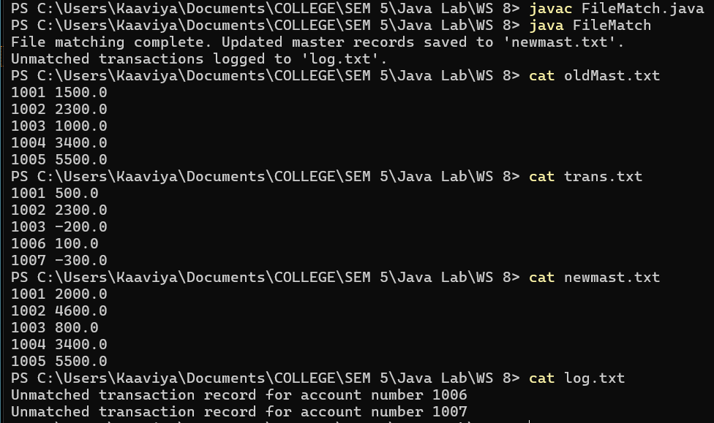

—------------------------------------------------------------------------------------------------------------------

7. Write a java program to store objects to a file using ObjectOutputStream and read the same objects from a file using ObjectInputStream and display.

import java.io.*;

class Person implements Serializable {
private static final long serialVersionUID = 1L;
private String name;
private int age;

public Person(String name, int age) {
this.name = name;
this.age = age;
}

@Override
public String toString() {
return "Person{name='" + name + "', age=" + age + '}';
}
}

public class ObjectStreamExample {
public static void main(String[] args) {

Person person1 = new Person("Alice", 25);
Person person2 = new Person("Bob", 30);

String filename = "persons.dat";

try (ObjectOutputStream out = new ObjectOutputStream(new FileOutputStream(filename)))
{
out.writeObject(person1);
out.writeObject(person2);
System.out.println("Objects written to file successfully.");
} catch (IOException e) {
System.out.println("Error writing objects to file: " + e.getMessage());
}

try (ObjectInputStream in = new ObjectInputStream(new FileInputStream(filename)))
{
Person p1 = (Person) in.readObject();
Person p2 = (Person) in.readObject();
System.out.println("Objects read from file:");
System.out.println(p1);
System.out.println(p2);
} catch (IOException | ClassNotFoundException e) {
System.out.println("Error reading objects from file: " + e.getMessage());
}
}
}





